A PROJECT REPORT ON

“Transformer Conversational Chatbot Using Tensorflow 2.0”

**SUBMITTED IN PARTIAL FULFILLMENT OF THE**

**REQUIREMENTS OF THE DEGREE OF**

Bachelor of Engineering

BY

**Kshitij Zunjarrao**

**Gaurav Gurav**

**Omkar Mhatre**

Under the guidance of

**Prof. Nikhil Raje**



**DEPARTMENT OF COMPUTER ENGINEERING**

**Pillai HOC College of Engineering and Technology, Rasayani.**

**Pillai HOCL Educational Campus, HOCL Colony,Rasayani,**

**Tal: Khalapur, Dist: Raigad 410207**

**UNIVERSITY OF MUMBAI**

**[2020-2021]**

**Mahatma Education Society's**

**Pillai HOC College of Engineering and Technology,**

**Rasayani-410207**

**2019-2020**



**CERTIFICATE**

This is to certify that the project entitled **“Transformer Conversational Chatbot Using Tensorflow 2.0”** is a bonfire work of **“Kshitij Zunjarrao, Gaurav Gurav and Omkar Mhatre”** submitted to the University of Mumbai in partial fulfilment of the requirement for the award of the degree of “**B.E**.” in “**Computer Engineering**”

_________________________

(**Prof. Nikhil Raje**)

Guide

__________________________ ________________________

(**Dr. Ashok M. Kanthe**) (**Dr. Mathue**)

Head of Department Principal

**Project Report Approval for B.E.**

This project report entitled **“Transformer Conversational Chatbot Using Tensorflow 2.0”** by **“Kshitij Zunjarrao, Gaurav Gurav, Omkar Mhatre”** is approved for the degree of Computer Engineering.

Examiners:

1 ---------------------------

2----------------------------

Date:

Place:

**DECLARATION**

We declare that this written submission represents my ideas in my own words and where others' ideas or words have been included, I have adequately cited and referenced the original sources. I also declare that I have adhered to all principles of academic honesty and integrity and have not misrepresented or fabricated or falsified any idea/data/fact/source in my submission. I understand that any violation of the above will be cause for disciplinary action by the Institute and can also evoke penal action from the sources which have thus not been properly cited or from whom proper permission has not been taken when needed.

-----------------------------------------

(**Kshitij Zunjarrao**)

-----------------------------------------

(**Gaurav Gurav**)

-----------------------------------------

(**Omkar Mhatre**)

# **TABLE OF CONTENT**

**ABSTRACT i**

**ABBREVIATIONS ii**

**LISTOFFIGURES iii**

**1.** **INTRODUCTION 01**

1.1 Background 02

1.2 Relevance 03

1.3 Organization of ProjectReport

**2.** **LITERATURE SURVEY 04**

2.1 ExistingSystems

2.2 Problem Statement

**3.** **REQUIREMENT GATHERING**

3.1 Software and HardwareRequirements

**4.** **PLAN OF THE PROJECT**

4.1.Incremental Model

4.2 Proposed System Architecture

4.3.1 Gantt Chart- Phase 1

4.3.2 Gantt Chart- Phase 2

**5.** **PROJECT ANALYSIS**

5.1 UseCaseDiagram

5.2 Activity Diagram

5.3 SequenceDiagram

**6.** **PROJECT DESIGN**

6.1 ClassDiagram

6.2.1 Data flow diagram: Level 0

6.2.2 Data flow diagram: Level 1

**7. REFERENCES**

**ACKNOWLEDGMENT**

# **ABSTRACT**

This project presents a Dialogue Generation or Intelligent Conversational chatbot development using Artificial Neural network or Deep Neural Network . Machine Learning technique is an interesting problem in the field of Natural Language Processing.Chatbots are software used in the entertainment industry, businesses and user support. Chatbots are modeled on various techniques such as knowledge base, machine learning based. Machine learning based chatbots yield more practical results. Chatbot which gives responses based on the context of conversation tends to be more user friendly. The chatbot we are proposing demonstrates a method of developing chatbot which can follow the context of the conversation. This model helps to deal with the messages to reply immediately with more human-like conversation. In this model, we have developed intelligent conversational chatbot using state of the art techniques proposed in recently published research papers. For developing intelligent chatbot, We have used Google’s tensorflow 2.0 Model which is based on Sequence to Sequence(Seq2Seq) modeling with encoder-decoder architecture. This encoder-decoder is using Transformer with bi-directional Transformer.

This model is useful for the people who have lack of time to deal with the other peoples, the messages come on their social platforms, they can easily answer them without spending time on it with less cost. It is useful for companies, businesses, government organizations and non-profit organizations, financial organizations like banks, credit card companies, businesses like online retail stores and start-ups.

Keywords-DNN; NLP ;DRL; ANN;

**ABBREVIATIONS**

**OS-** Operating System

**GUI-** Graphical User Interface

**HMM-** Hidden Markov Model

**DTW-** Dynamic Time Warping

**ANN-** Artificial Neural Network

**NLP-** Natural Language Processing

**DNN-** Deep Neural Network

**DRL**- Deep Reinforcement Learning

**LIST OF FIGURES**

**LIST OF FIGURES**

**Figure No. Figure Name Page No**

4.1 Incremental Model 10

4.2 Proposed System Architecture 11

4.3.1 Plan Phase-1(Gantt Chart) 12

4.3.1 Plan Phase-2(Gantt Chart) 13

5.1 Use Case Diagrams 15

5.2 Activity Diagram 16

5.3 Sequence Diagrams 17

6. 1 Class Diagram 19

6.2.1 Data flow diagram: Level0 20

6.2.2 Data flow diagram: Level1 21

The report is divided into 7 chapters.

Chapter 1: Describes about the Background of the”Conversational Chatbots”.

Chapter 2: Describes about the literature review of project.

Chapter 3: Describes about hardware and software that are used in the developed system.

Chapter 4: Describes the methodology and block diagram of the developed system.

Chapter 5: Describes about Project analysis.

Chapter 6: Describes about the Design Model used in the developed system.

Chapter 7: Describes about the reference

# **Chapter 1**

1. **INTRODUCTION**

Chatbots is a computer program that conducts a conversation through auditory or textual methods. Conversational chatbots is a trending topic in artificial intelligence research. These bots are often powered by retrieval-based models, which outputs predefined responses to questions of certain forms. Chatbots, too often are unable to understand our intentions, have trouble getting us the correct information, and are sometimes just exasperatingly difficult to deal with. Deep learning is one of the most effective methods in tackling this tough task. TensorFlow 2.0 is with all changes and improvements that can be used for building complicated models with ease.. Implementing Multi-Head Attention with Model subclassing. Implementing a Transformer with Functional API.

1.1 Background

Conversational Chatbots are highly used in the market for entertainment purposes or the Enterprise Purpose. People interact with chatbot for resolving their queries or sometimes lonely people talk with them to overcome their feeling of being alone. Most of the companies, financial sectors. Used chatbots to save their time as well as money so what happened because of the using chatbot by most people chatbot in demand. The existing chatbot system deals with the people but in a more artificial way, the implementation of such chabots is a little bit difficult.

1.2 Relevance

There has been most of the recent development and experimentation in chatbot systems. Apart from traditional chatbot development techniques that use rule-based techniques, or simple machine learning algorithms, many advanced chatbots are using advanced Natural Language Processing (NLP) techniques and Deep Learning Techniques like

Deep Neural Network (DNN) and Deep Reinforcement Learning (DRL).

With the help of these chatbots companies, financial sectors, banks can easily interact with their customers.

Chatbots provide invaluable contributions to organizations and users.

Chatbots are based on the rules based, generative based chatbots, cryptid/quick reply chatbots, nlp chatbots.

Businesses which provide customer services benefit from the technology in order to improve self-service in a way that enriches customer experience and reduces organizational costs. For that one of the best applications is chatbots.

Chapter 2

**LITERATURE SURVEY**

A literature survey or a literature review in a project report is that section which shows the various analyses and research made in the field of your interest and the results already published, considering the various parameters of the project and the extent of the project.

Mohammad Javed “Implement Word Segmentation (tokenization)” Methods used Calculating all character spaces Results involves mathematical calculations hence proves to be slower than the others.

Naeun Lee ‘’Implement word segmentation (tokenization)’’ Using NLTK package which involves inbuilt tokenizer results get Easy to implement, as it does not require any coding. Faster and more accurate.

Tao Jiang “To implement word segmentation (tokenization)” Using

Conditional Random Fields result. This algorithm proves to be more accurate and less complex than the first but less efficient as compared to NLTK.

Jerome R. Bellagarda “To implement POS Tagging” methods used Using the latent analogy algorithm, result get Requires training of large amounts of data. Hence involves complexity.

Liner Yang “To implement POS Tagging” methods used Using neural network algorithms. As the algorithm works in layers, it provides high accuracy, but is not time efficient.

None “To implement POS Tagging” algorithm Using NLTK, output get Provides above average accuracy at minimum complexity.

Bo Chen “To create a dependency parser” Using a dependency tree to understand the dependencies. Result get Traditional method. Accuracy depends on the training of the data.

Zhenghua Li “To create a dependency parser” Using a graph data structure for the implementation of the parser result, get Improvised version of the above mentioned algorithm. Provides higher visibility,

understandability and improves accuracy.

LinHua Gao “Synonym detection and extraction” Dictionary method

Result get Traditional method. Requires to maintain a dictionary of synonyms wordwise. Provides less accuracy then self training models.

Sijun Qin “Synonym detection and extraction” Feature selection method by calculating feature polarity. It provides high accuracy and less complexity as compared to the dictionary method.

2.1 Existing System

In the past , Giving reply to the messages manually was very time consuming. These existing systems majority of them used simple rule based techniques. Most of this chatbots are developed for restricted domain, Fail to emulate real human conversation & lacks flexibility in functioning.In long conversations reduced relevancy in dialogue generation.

2.2Problem Statement

In the proposed system conversational chatbot is implemented by using a transformer which aims to make cutting-edge NLP easier to use for everyone. By using that we can achieve more human-like conversations by the computers and are not able to reduce relevancy in conversation. Make the chatbot building complicated method a little bit easier.

Chapter 3

**3. REQUIREMENT GATHERING**

**3.1 Software and Hardware Requirement**

**For developing the Transformer Chatbot**

**Hardware:**

Processor: Intel i5 or higher

RAM: 8 GB RAM minimum, 16 GB RAM recommended

Space on disk: 2 GB of available disk space minimum, 4 GB Recommended

Display: 1280 x 800 minimum screen resolution.

**Software:**

Tools: Anaconda Environment

Jupyter Notebook and Spider

Technologies: Tensorflow ML Library, Transformer, Python

For Running The Application:  
 Laptop with Atleast 8 GM RAM, i5 processor, 64 bit CPU

Chapter 4

**4. PLAN OF THE PROJECT**

**4.1 Incremental Model**

Incremental Model is a process of software development where requirements are broken down into multiple standalone modules of software development cycle. Incremental development is done in steps from analysis design, implementation, testing/verification, maintenance.

Each iteration passes through the **requirements, design, coding and testing phases.** And each subsequent release of the system adds function to the previous release until all designed functionality has been implemented.

The system is put into production when the first increment is delivered. The first increment is often a core product where the basic requirements are addressed, and supplementary features are added in the next increments. Once the core product is analysed by the client, there is plan development for the next increment.

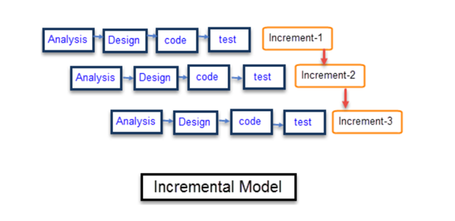Fig: 4.1 Incremental Model

**4.2 Proposed System Architecture**

This proposed system is developed to give a reply to text messages automatically by the computer. Instead of giving the reply manually by some other person used to talk with the user and customer. In this model the reply was more human conversational oriented. Modern Machine Learning Libraries and the natural language processing techniques can process the user input and give the output in the form of text. The generated output is provided to the input to improve the accuracy.

In this system users need to give the input in the form of text. Which will process the text form using certain tokenization and nlp methods. And system process it and provide output the user.

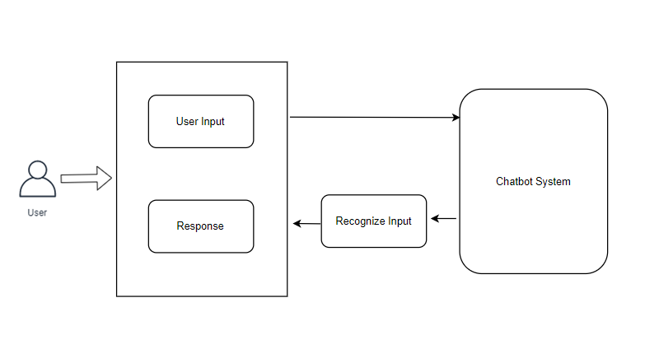

**4.3 Project Plan (Gantt Chart)**

**4.3.1 Plan Phase-1**

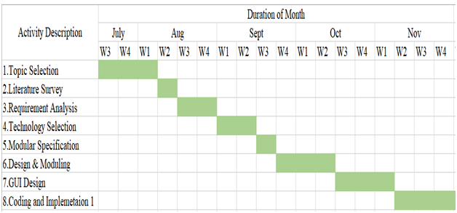

Fig: 4.3.1 Plan Phase-1(Gantt Chart)

**4.3.2 Plan Phase-2**

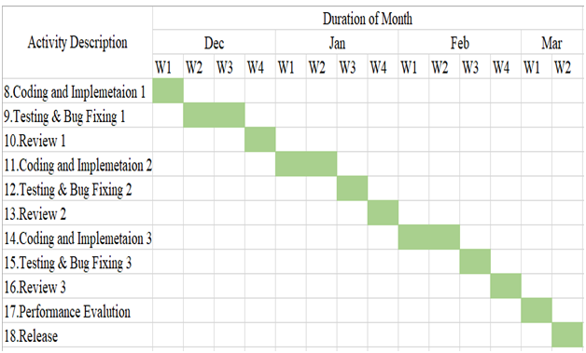

**Fig: 4.3.2 Plan Phase-2(Gantt Chart)**

Chapter 5

**5. PROJECT ANALYSIS**

**5.1 Use Case Diagrams**

A use case diagram at its simplest is a representation of a user's interaction with the system and depicting the specifications of a use case. A use case diagram can portray the different types of users of a system and the various ways that they interact with the system. This type of diagram is typically used in conjunction with the textual use case.UML Use Case Diagrams. Use case diagrams are usually referred to as behaviour diagrams used to describe a set of actions (use cases) that some system or systems (subject) should or can perform in collaboration with one or more external users of the system (actors).The purpose of the use case diagrams is simply to provide the high level view of the system and convey the requirements in laypeople's terms for the stakeholders. Additional diagrams and documentation can be used to provide a complete functional and technical view of the system.

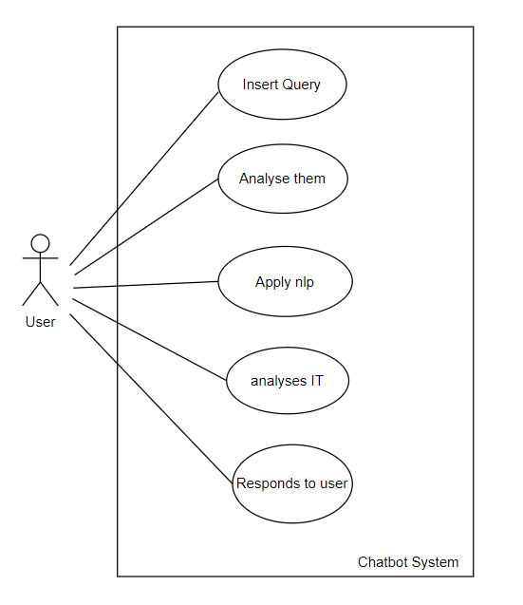

**5.2 Use Case Analysis - Activity Diagram**

An activity diagram shows the flow from activity to activity. And is an ongoing non-atomic execution within a state machine. Activities ultimately result in some action, which is made up of executable atomic computations that result in a change in state of the system or the return of a value. The basic purpose of activity diagrams is similar to the other four diagrams. It captures the dynamic behaviour of the system. Other four diagrams are used to show the message flow from one object to another but activity diagram is used to show message flow from one activity to another.

Activity is a particular operation of the system. Activity diagrams are not only used for visualizing the dynamic nature of a system, but they are also used to construct the executable system by using forward and reverse engineering techniques

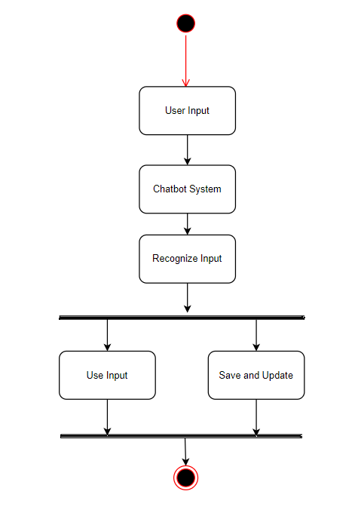

**5.3Use Case Analysis - Sequence Diagrams**

Sequence diagram displays the time sequence of the objects participating in the interaction. Sequence diagrams are used to visualize and explore the interaction between the users, screens and the object instances within the system. A sequence diagram is a type of interaction diagram because it describes how and in what order a group of objects works together. These diagrams are used by software developers and business professionals to understand requirements for a new system or to document an existing process. Sequence diagrams are sometimes known as event diagrams or event scenarios.

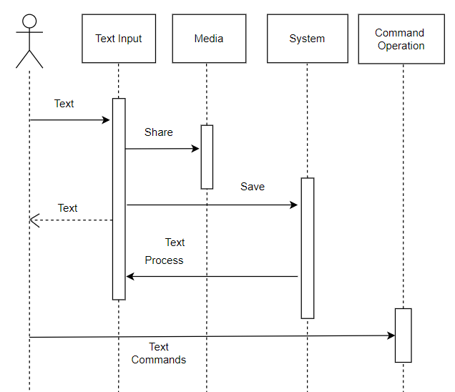

Chapter 6

**6. PROJECT DESIGN**

**6. 1 Design Model - Class Diagram (Detailed Design)**

Class diagrams are one of the most useful types of diagrams in UML as they clearly map out the structure of a particular system by modelling its classes, attributes, operations, and relationships between objects. With our UML diagramming software, creating these diagrams is not as overwhelming as it might appear. This guide will show you how to understand, plan, and create your own class diagrams.

Class diagram is a static diagram. It represents the static view of an application. Class diagram is not only used for visualizing, describing, and documenting different aspects of a system but also for constructing executable code of the software application. Class diagram describes the attributes and operations of a class and also the constraints imposed on the system. The class diagrams are widely used in the modelling of object-oriented systems because they are the only UML diagrams, which can be mapped directly with object-oriented languages.

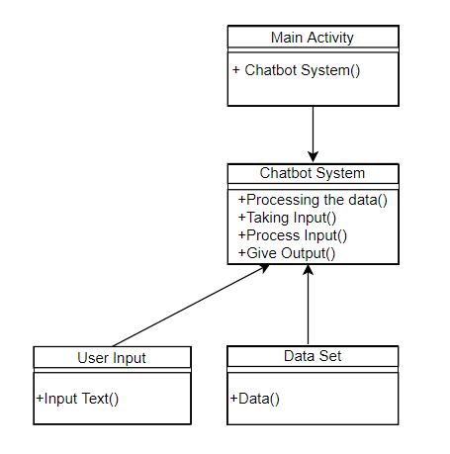

**6. 2 Design Model - Function Specs (Data flow diagrams)**

A data flow diagram (DFD) is a graphical representation of the "flow" of data through an information system, modelling its process aspects. A DFD is often used as a preliminary step to create an overview of the system without going into great detail, which can later be elaborated. DFDs can also be used for the visualization ofdata processing (structured design).

A DFD shows what kind of information will be input to and output from the system, how the data will advance through the system, and where the data will be stored. It does not show information about process timing or whether processes will operate in sequence or in parallel, unlike a traditional structuredflowchart which focuses on control flow, or a UML activity workflow diagram, which presents both control and dataflows as a unified model.

**6.2.1 Data flow diagram: Level0**

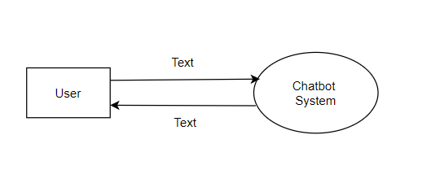

**6.2.2 Data flow diagram: Level1**

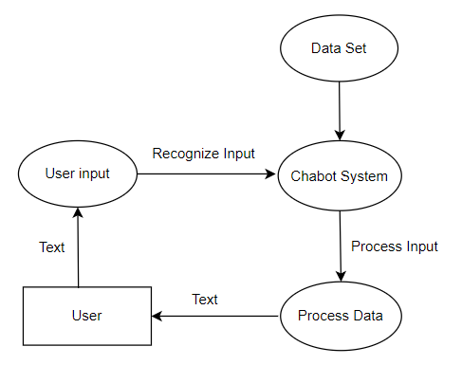

Chapter 7

**REFERENCE**

[1] A. Vichare, A. Gyani, Y. Shrikhande and N. Rathod, "A chatbot system demonstrating Intelligent Behaviour using NLP," in International Journal of Advanced Research in Computer Engineering & Technology (IJARCET), 10 October 2015. J. Clerk Maxwell, A Treatise on Electricity and Magnetism, 3rd ed., vol. 2. Oxford: Clarendon, 1892, pp. 68-73.

[2] R. Shah, S. Lahoti and P. L. K., "An Intelligent Chat-bot using Natural Language Processing," in International Journal of Engineering Research, 1 May 2017. T. L. Gilbert, Formulation, Foundations and Applications of the Phenomenological Theory of Ferromagnetism, Ph.D. dissertation, Illinois Inst. Tech., Chicago, IL, 1956, unpublished.

[3] A. Sordoni, M. Galley, M. Auli, C. Brockett, Y. Ji, M. Mitchell, J.-Y. Nie, J. Gao and B. Dolan, "A Neural Network Approach to Context-Sensitive Generation of Conversational Responses," in arXiv:1506.06714, 22 June 2015.S. O. Demokritov and V. E. Demidov, “Micro-Brillouin light scattering spectroscopy of magnetic nanostructures,” IEEE Trans. Magn.,to be published.

[4] "Contextual chatbots using tensorflow," 2017. [Online]. Available: <https://chatbotsmagazine.com/contextual-chat-bots-with-tensorflow-> 4391749d0077.Y. Yorozu, M. Hirano, K. Oka, and Y. Tagawa, “Electron spectroscopy studies on magneto-optical media and plastic substrate interface,” IEEE Transl. J. Magn. Jpn., vol. 2, pp. 740-741, August 1987 [Dig. 9th Annual Conf. Magn. Jpn., p. 301, 1982].

[5] "Make bots great again," 30 September 2016. [Online]. Available: <http://blog.datatonic.com/2016/09/make-bots-great-again.html>.

[6] "Cornell University Library," 2014. [Online]. Available: https://arxiv.org/ftp/arxiv/papers/1408/1408.6762.pdf.

[7] "Text Classification using Neural Networks," 2017. [Online]. Available: <https://machinelearnings.co/text-classification-using-neural-networksf5cd7b8765c6>.

[8] B.A shawar and E. Atwell, “Evaluation of Chatbot Information System, in Eighth Maghrebian Conference on Software Engineering and Artificial Intelligence.

[9] B.A shawar and E. Atwell, “JLCL,”2007. [Online]. Available: http://www.jlcl.org/2007_heft1/Bayan_Abushawar_and_Eric_Atwell.pdf

[10] B. Setiaji and F. W. Wibowo, "Chatbot Using a Knowledge in Database: Human-to-Machine Conversation Modeling," in Intelligent \ Systems, Modelling and Simulation (ISMS), 2016 7th International Conference on, Bangkok, Thailand.

[11] B. R. Ranoliya, N. Raghuwanshi and S. Singh, "Chatbot for university related FAQs," in Advances in Computing, Communications and Informatics (ICACCI), 2017.

# 

# 

# 

# 

# 

# 

# 

# 

# 

# ACKNOWLEDGEMENT

This project report would not have come into reality without the able guidance, support and wishes of all those who stand by us in the development. We wish to give our special thanks to our guide Prof. Nikhil Raje for their timely advice and guidance.

We humbly thank our project coordinator, Prof.Srijit Bhattacharjee and our Head of Department, Dr. Ashok Kanthe for their valuable guidance and unending support despite a very busy work schedule. The cheerful spirit they radiated all the time fuelled our desire to excel in the work that we had undertaken.

We acknowledge all the staff members of the department of Computer Engineering for their help and suggestions during various phases of this project work. It’s difficult to forget our eminent supporters that are my family members and friends who are always there encouraging us in my every deed.

Thanking You

Kshitij Zunjarrao

Gaurav Gurav

Omkar Mhatre